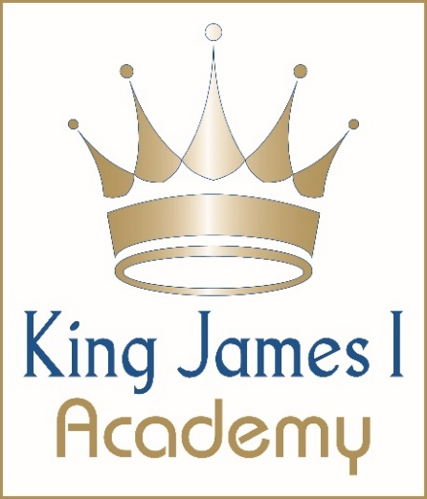

King James I Academy
SEND Information Report 2025–2026
SENCo: Miss C. Wall – kingjames@kj1a.com – 01388 603388
Assistant SENCo: Mrs R. Coy – kingjames@kj1a.com – 01388 603388
SEND Governor: Mrs E. Varley – kingjames@kj1a.com – 01388 603388
Department Context
September 2025

 | Yr 7 | Yr 8 | Yr 9 | Yr 10 | Yr 11 | Total
EHCP | 8 | 5 | 5 | 4 | 5 | 27
K Status | 37 | 40 | 30 | 31 | 28 | 166
CIC | 4 | 2 | 0 | 0 | 0 | 6
EAL | 9 | 3 | 4 | 4 | 6 | 23
Total | 168 | 50 | 39 | 39 | 39

SEN Need September 2025
 | C&L | C&I | SEMH | PD
7 | 18 | 10 | 15 | 2
8 | 21 | 12 | 10 | 2
9 | 14 | 6 | 10 | 3
10 | 16 | 8 | 6 | 5
11 | 10 | 12 | 10 | 1

1. Vision and Principles for SEND
At King James I Academy, our vision is to be an exceptional learning establishment that offers extraordinary opportunities for every student to reach their full potential as ambitious, confident, and independent learners.
We are fully inclusive and committed to removing barriers to learning through high-quality teaching, targeted support, and inclusive practices.
The aim of our SEND Department is:
“To ensure that all students with additional needs are identified, referred, and appropriately supported through timely review, enabling academic progress and personal growth.”
We celebrate diversity, value every learner, and work together to ensure that all students experience success, achievement, and inclusion in all areas of school life.

2. Identification of SEND
We identify and support students with SEND in line with the SEND Code of Practice (2015) and the four broad areas of need:
1. Communication and Interaction (C&I)
2. Cognition and Learning (C&L)
3. Social, Emotional and Mental Health (SEMH)
4. Sensory and/or Physical Difficulties (PD)
Early Identification and Assessment occurs through transition data, screening, teacher and parent observations, and external advice. We use the Graduated Approach – Assess, Plan, Do, Review (APDR).

3. The Graduated Response
Quality First Teaching (QFT) ensures differentiation and adaptive learning for all students. If additional support is required, a SEN Support Plan is created in collaboration with parents, carers, and students. Plans are reviewed termly through the APDR cycle. If a student requires support beyond this, we work with Durham Local Authority to request an EHCP assessment.

4. Supporting Students in Care (CIC)
Designated Teacher: Miss C. Wall
Governor for CIC: Mrs E. Varley
We work closely with Durham Virtual School and professionals to provide Personal Education Plans (PEPs) with appropriate targets and enrichment opportunities, using Pupil Premium Plus funding to raise achievement.

5. Curriculum, Teaching and Assessment
All teachers are responsible for ensuring access to an inclusive curriculum. Differentiated teaching, TA support, and targeted interventions support learning. Progress is monitored half-termly using SISRA Analytics.

6. Consulting with Parents/Carers and Students
We value parents and carers as partners in education. Engagement includes meetings, reviews, parents’ evenings, and email contact. Students take part in setting targets, reviews, and school initiatives such as Student Council and recruitment panels.

7. Equality and Accessibility
We promote equality, eliminate discrimination, and ensure accessibility for all students. Facilities include lift access, disabled toilets, parking, and adapted minibuses. Staff are trained in EVAC and manual handling.

8. Staff Training and Expertise
Our SEND team holds specialist qualifications, including NPQ SEND, psychometric testing, and safeguarding. All staff receive annual training in safeguarding, Prevent, FGM awareness, and SEND-specific CPD.

9. External Support and Partnerships
We collaborate with Durham SEND Casework Team, Educational Psychology, NHS services, CAMHS, SENDIASS, and other agencies to provide specialist support, assessment, and intervention.

10. Medical Support
We support students with medical needs through individual healthcare plans, regular reviews, and trained first aid staff. Parents are encouraged to share medical updates promptly.

11. Transitions
We plan carefully for transitions between primary, secondary, and post-16 education through visits, meetings, and enhanced transition support. Post-16 transitions include careers guidance and EHCP transition planning.

12. Anti-Bullying and Wellbeing
We hold the BIG Award for anti-bullying excellence. Students can report issues to tutors, Student Support Workers, or trained Anti-Bullying Ambassadors. We use restorative approaches and student surveys to improve wellbeing.

13. Compliments, Feedback, and Complaints
We welcome feedback and complaints can be raised with the SENCo or Headteacher. EHCP concerns should be directed to Durham’s Statutory Casework Team. Independent advice is available from Durham SENDIASS (www.durhamsendiass.info, sendiass@durham.gov.uk, 0191 587 3541).

14. Evaluating the Success of SEND Provision
We evaluate SEND provision through lesson observations, data tracking, stakeholder feedback, and monitoring by the SEND Governor. Ongoing CPD ensures continuous improvement in inclusive education.
Contact Information:
SENCo: Miss C. Wall
Assistant SENCo: Mrs R. Coy
SEND Governor: Mrs E. Varley
Email: kingjames@kj1a.com
Telephone: 01388 603388
King James I Academy is committed to promoting inclusion, equality, and excellence for all. Every child matters — every success counts.

